<https://docs.gradle.org/current/userguide/tutorial_using_tasks.html>

Java plugin – task ***

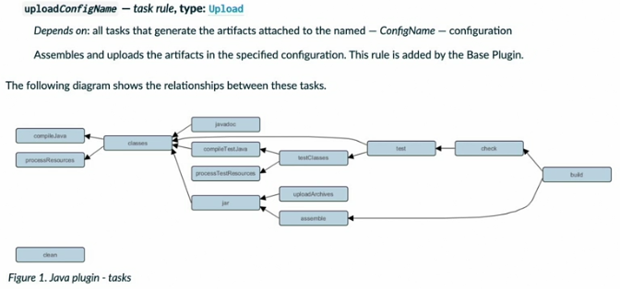

# D:\Gradle\Gradle for Java-Based Applications and Libraries

# Gradle for Java-Based Applications and Libraries

## 03 Anatomy of a simple Java project

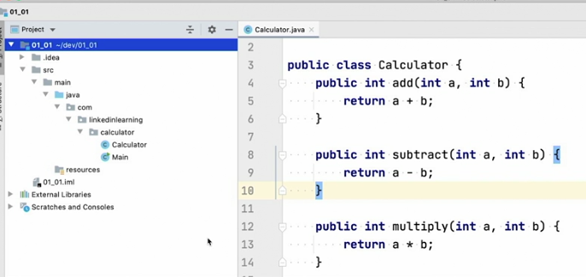

#### javac src/main/java/com/linkedinlearning/calculator/*.java -d out

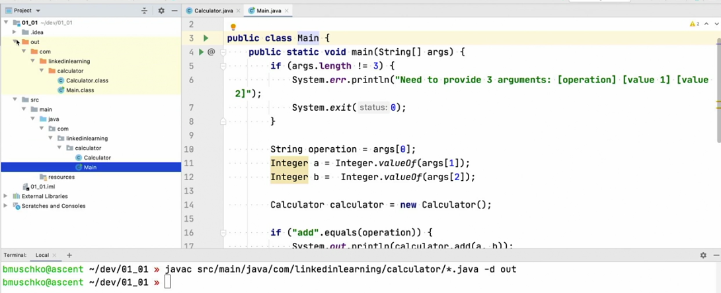

#### java cfv calculator.jar -c out .

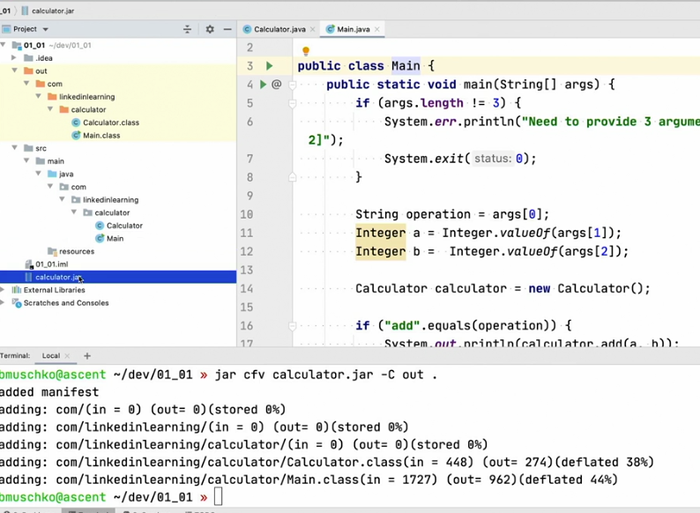

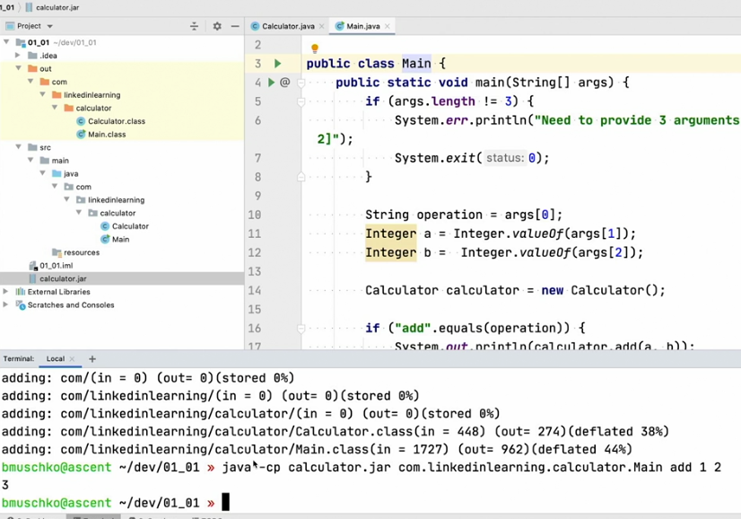

src/main/java/com/linkedinlearning/calculator/

Calculator.java

Main.java

javac src/main/java/com/linkedinlearning/calculator/*.java -d out

java cfv calculator.jar -c out .

#### javac cp calculator.jar com.linkedinlearning.calculator.Main add 1 2

3

## 04 Applying the Java plugin.mp4

https://docs.gradle.org/current/userguide/java-plugin.html 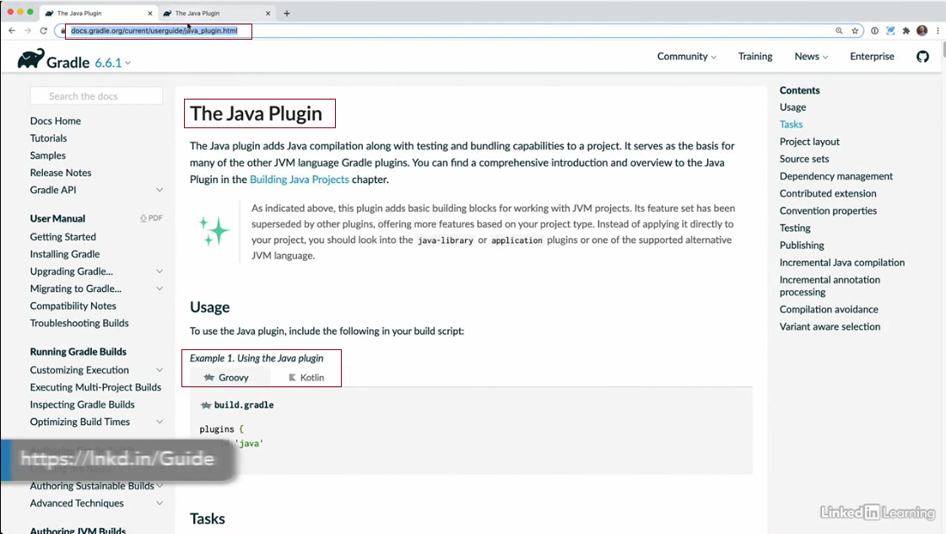

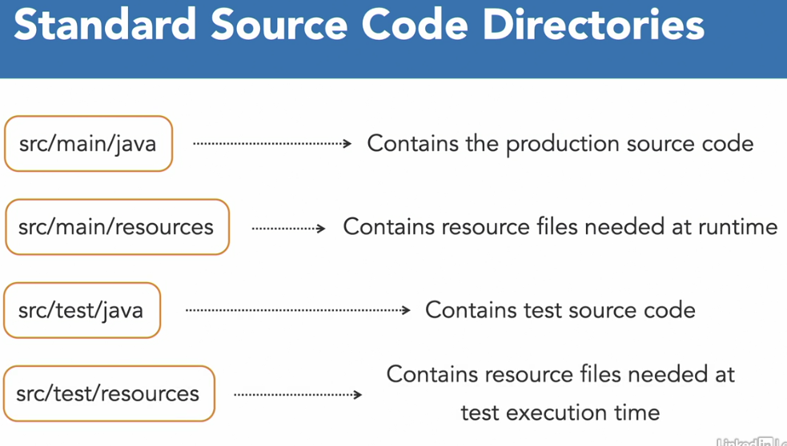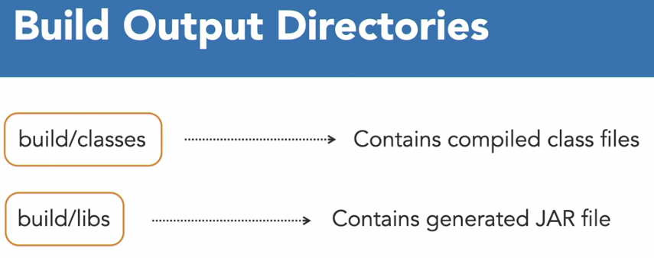

### Java plugin – task ***



### gradle wrapper

### ./gradle task

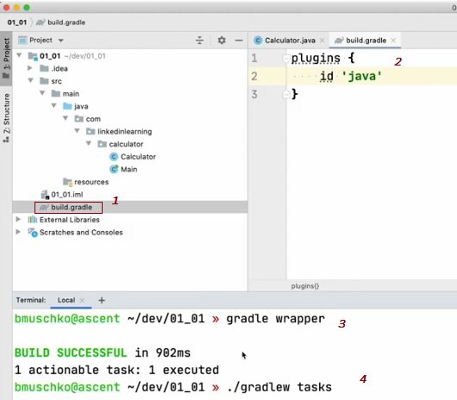

## 05 Compiling Java source code

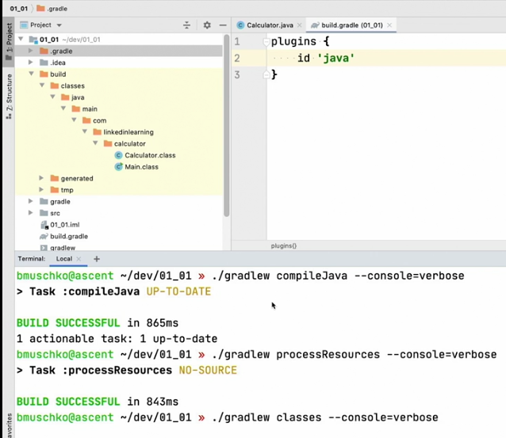

### ./gradlew compileJava -- console=verbose

### ./gradlew processResources -- console=verbose

### ./gradlew compileJava -- console=verbose

## 06 Packaging a JAR file

### ./gradle jar

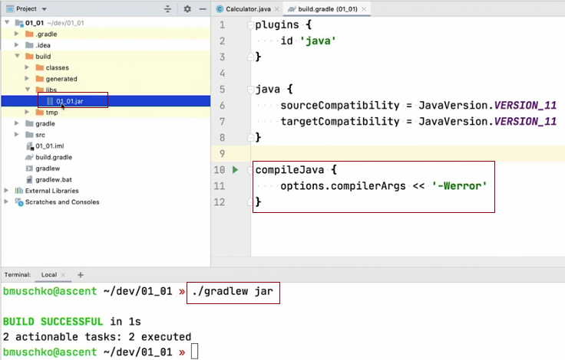

#### Rename the jar from "01_01. jar to "calculator.jar"

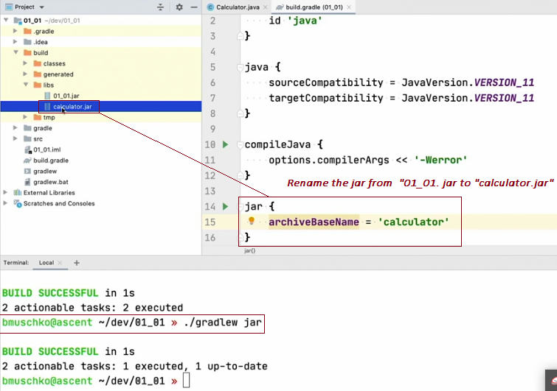

#### Version appended

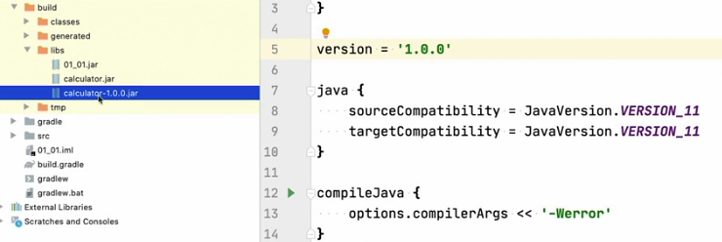

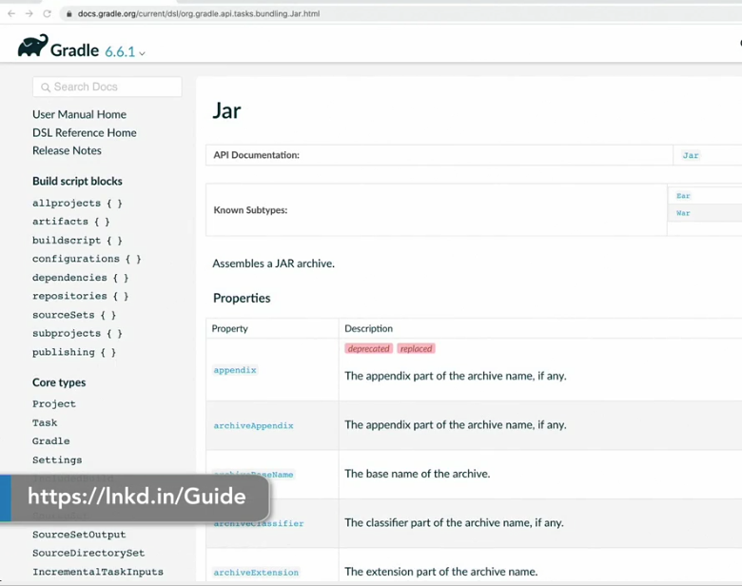

## 07 Exploring the Java Application plugin

### ./gradlew run –args=”add 1 2”

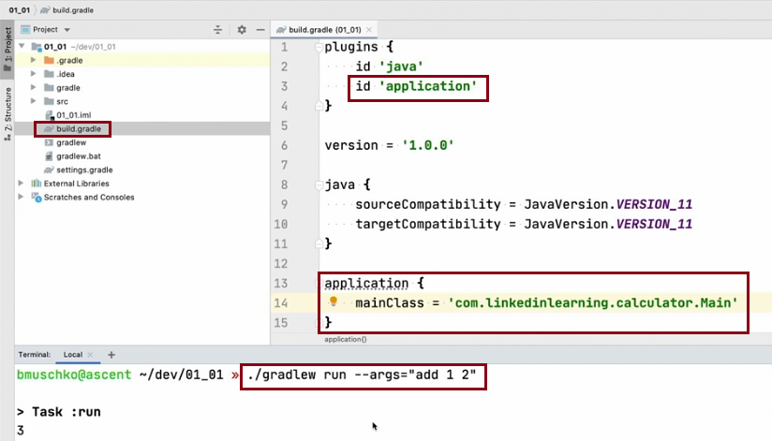

### ./gradlew installDist

#### cd build/install/calculator/bin

#### ./calculator add 1 2

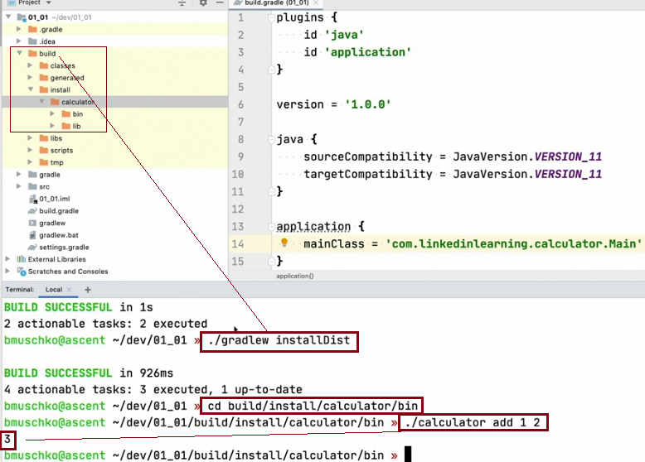

### ./gradlew distZip distTar

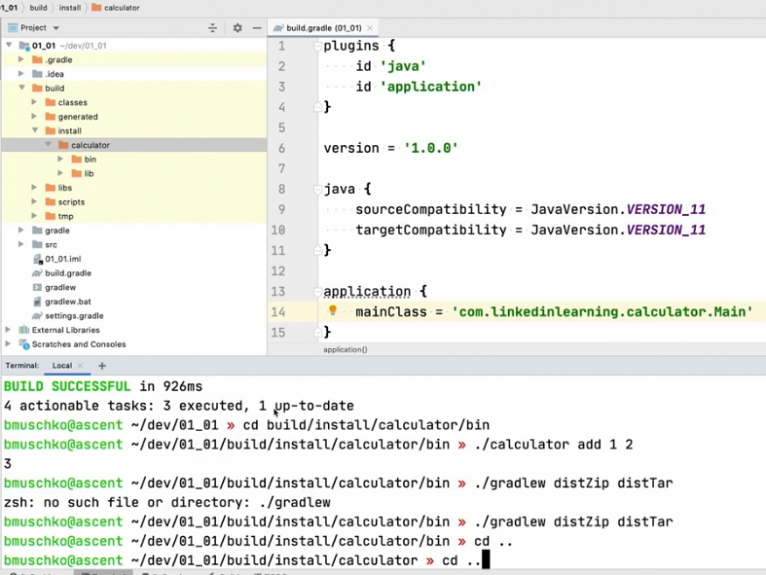

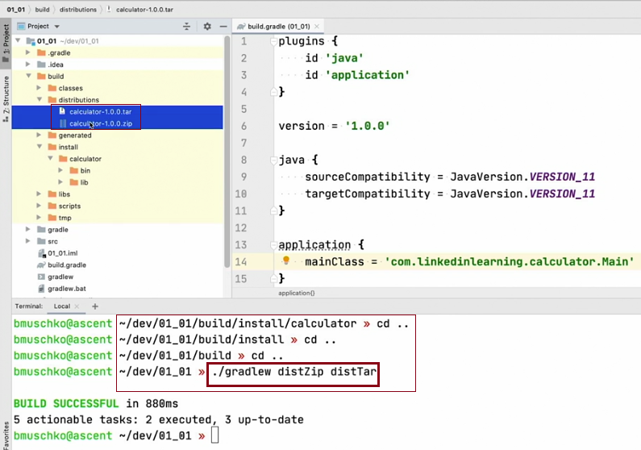

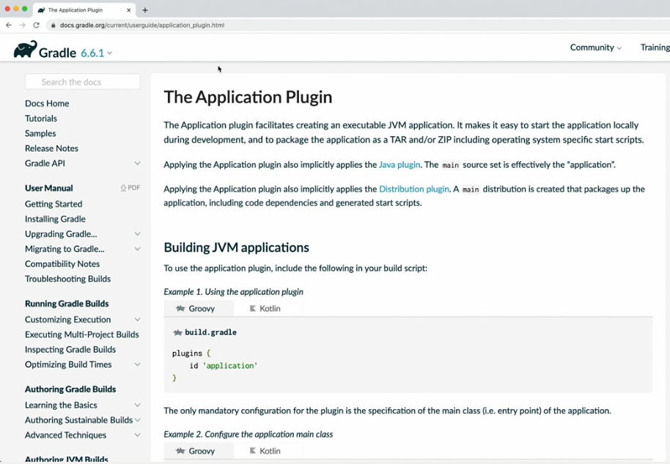

## 08 Challenge Generating Javadocs for a Java project

### ./gradlew task

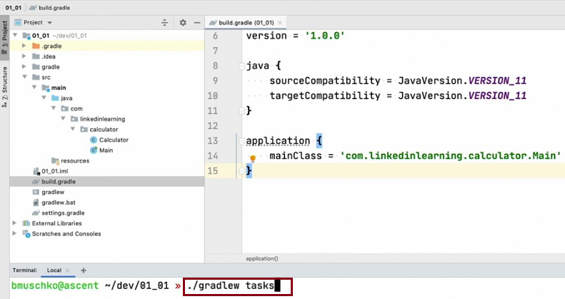

## 09 Solution Generating Javadocs for a Java project

### ./gradlew task

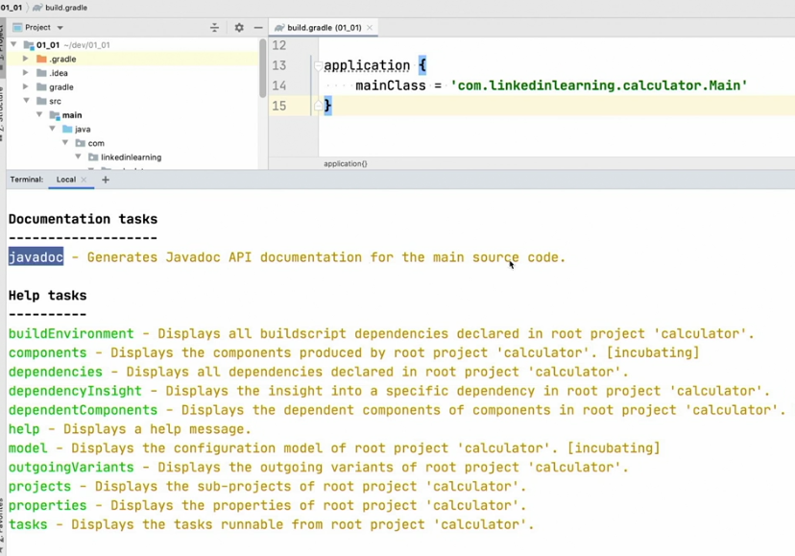

### ./gradlew javadoc

#### open build/docs/Javadoc/index.html

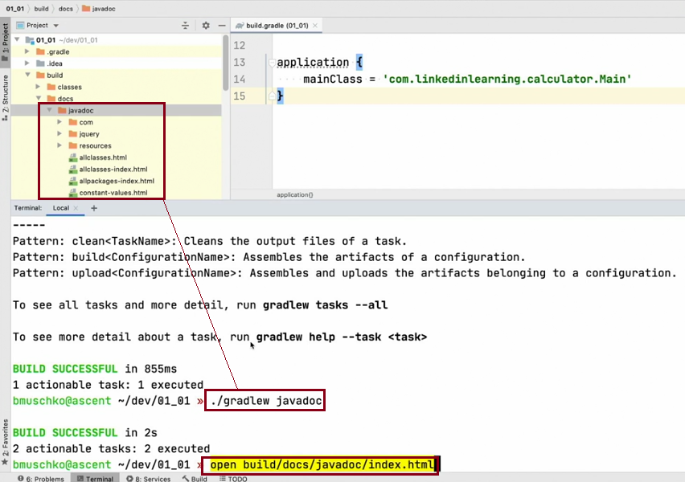

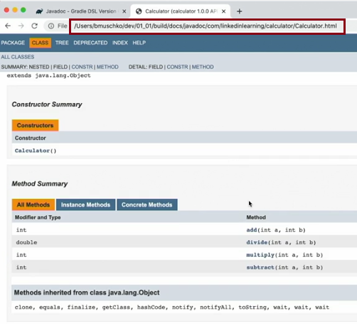

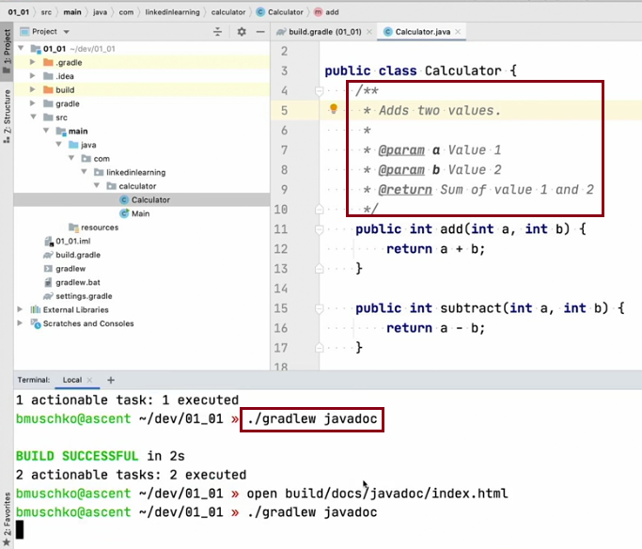

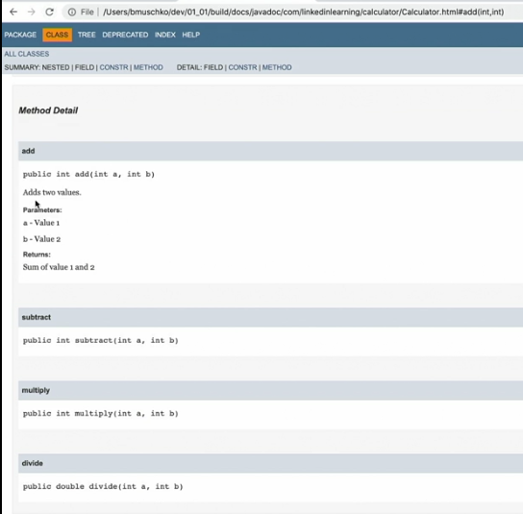

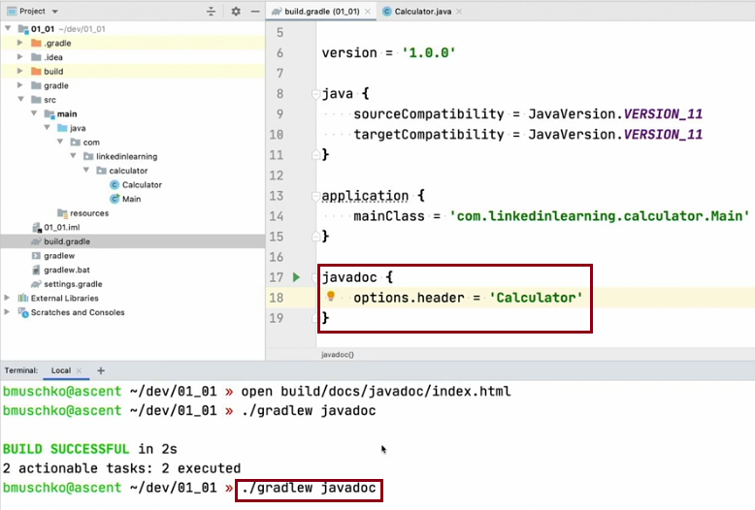

### ./gradlew clean Javadoc

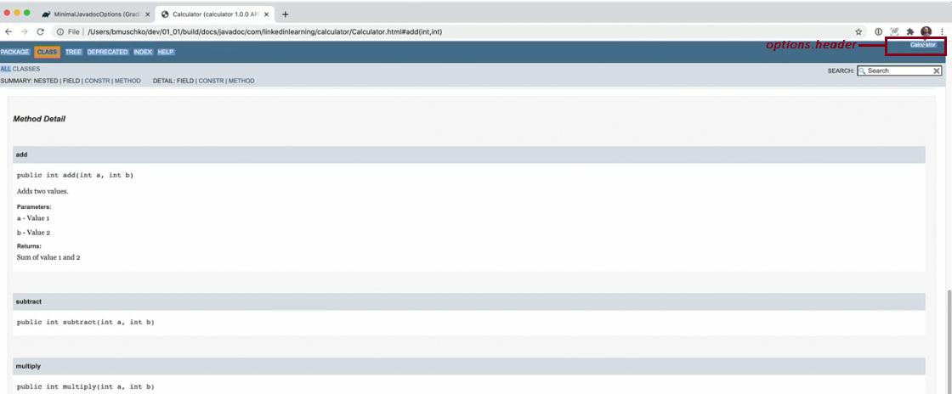

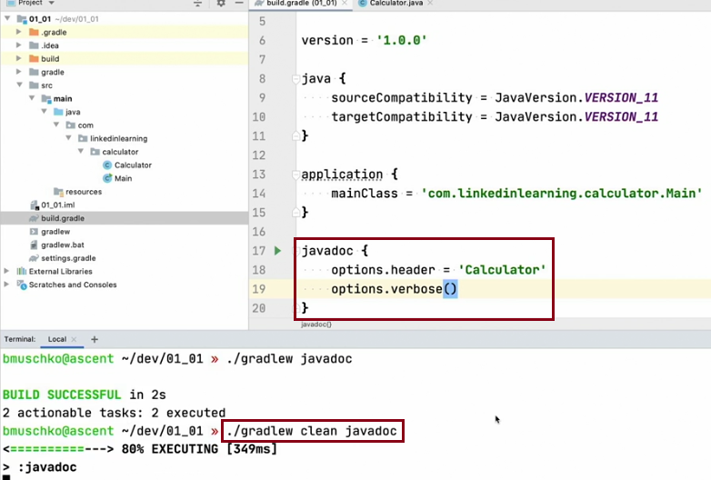

#### options.verbose()

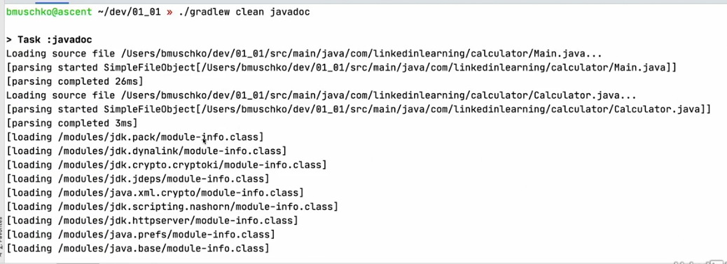

## 10 Mechanics of dependency management

### Dependency Resolution

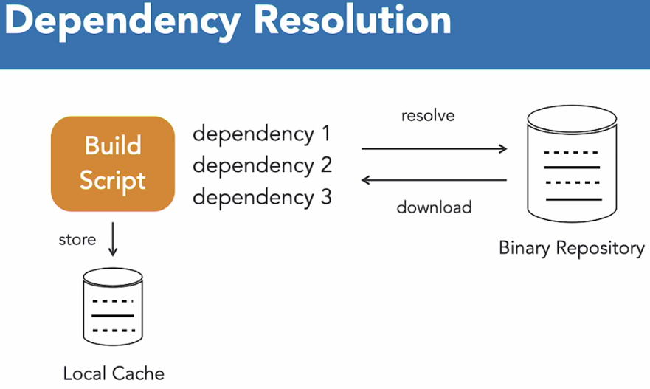

### Defining the Dependency Scope

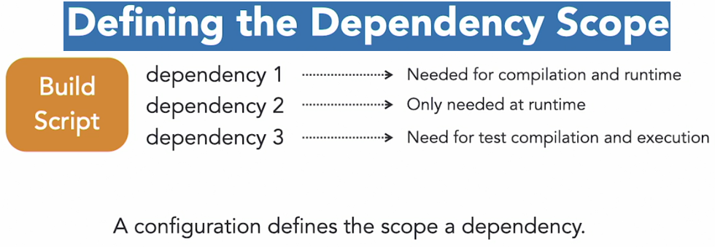

### Dependency Scope

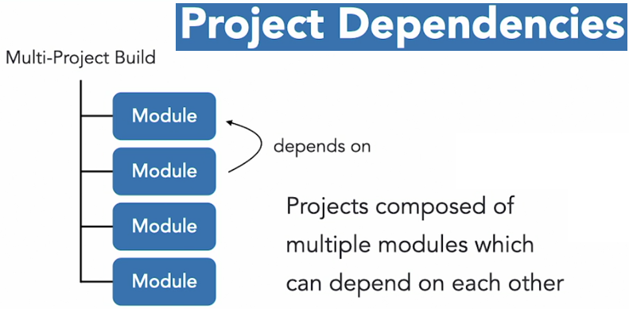

### Artifact Publishing

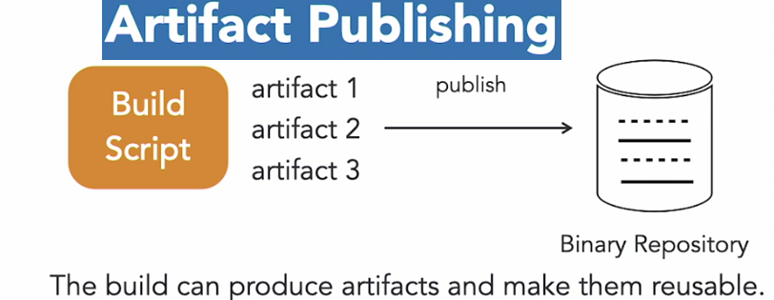

## 11 Declaring a dependency on an external library

### Dependency Coordinates

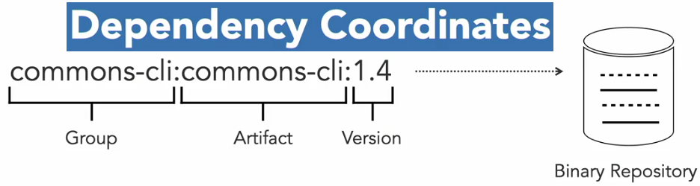

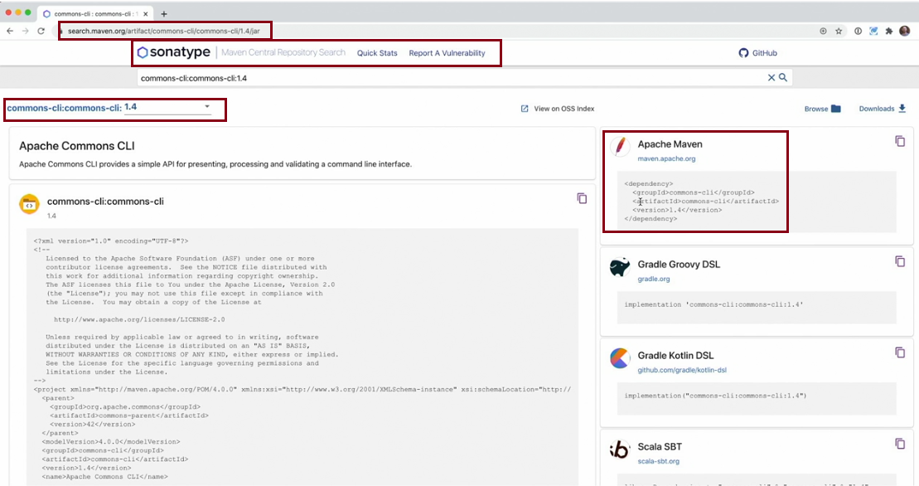

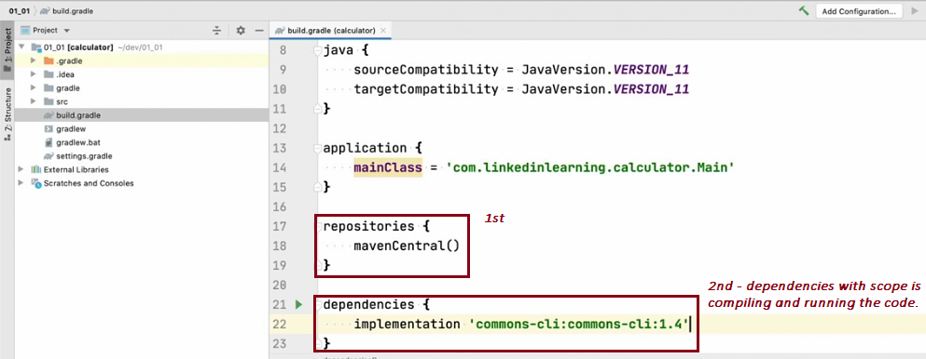

### ./gradlew installDist

#### cd build/install/calculator/bin

#### ./calculator –operation add --value1 1--value2 2

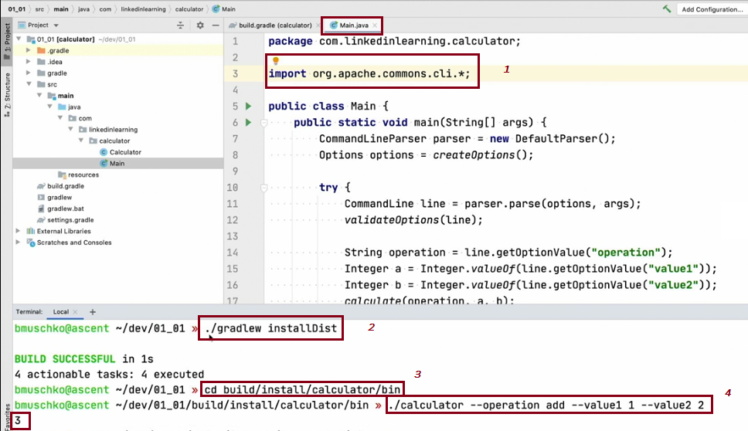

## 12 Rendering the dependency tree

### ./gradlew dependencies

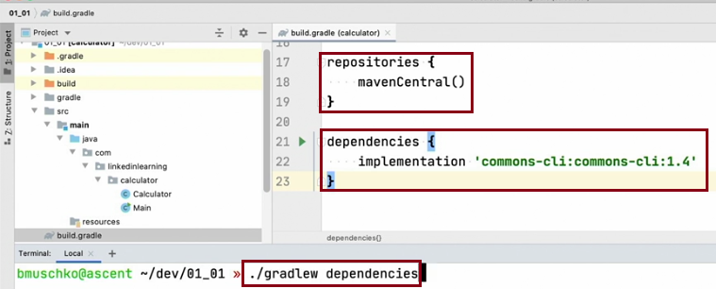

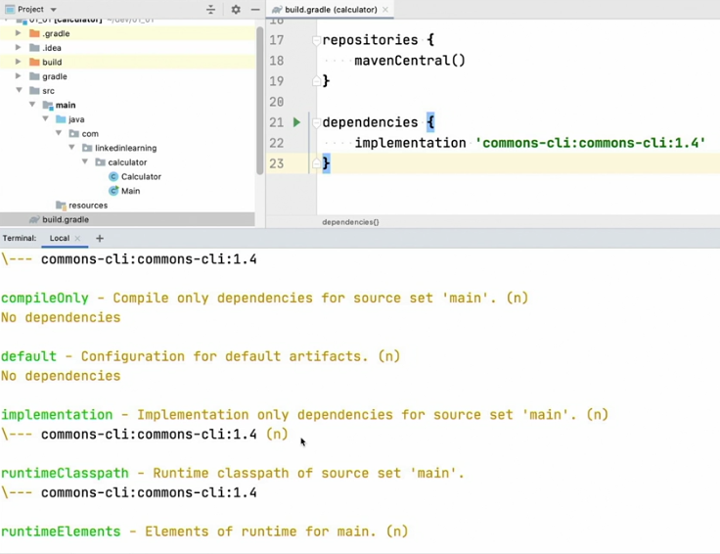

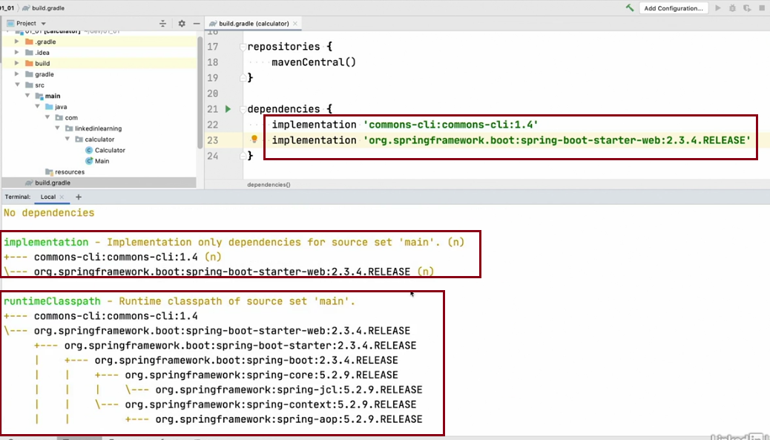

## 13 Declaring a project dependency

### ****Multi-Project Builds

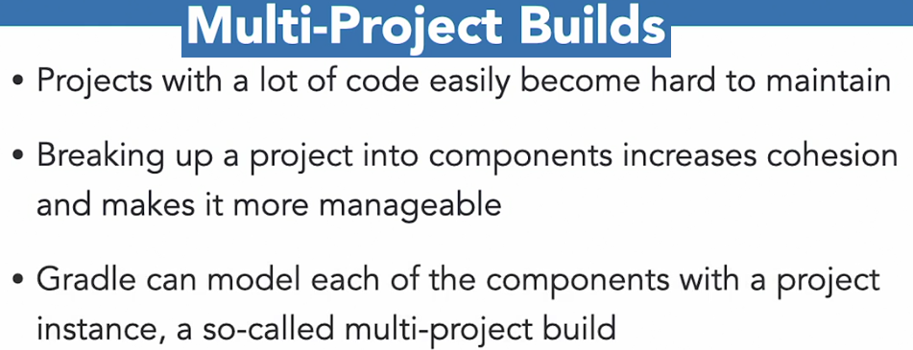

### D:\Gradle\Gradle for Java-Based Applications and Libraries\Ex_Files_Gradle_Java\Ex_Files_Gradle_Java\Exercise Files\chapter_2\02_04-end

### settings.gradle

rootProject.name = 'calculator'

include ':api', ':app'

### ./gradlew projects

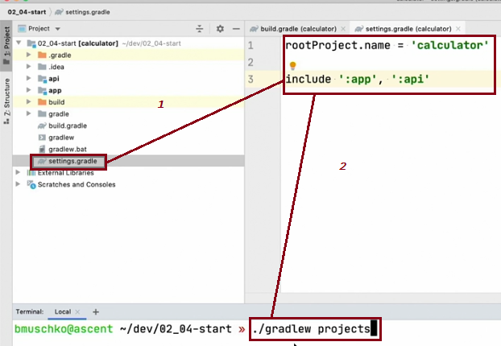

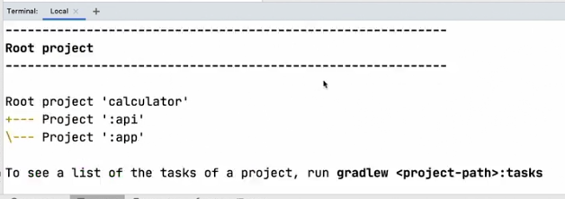

### ./gradlew classes

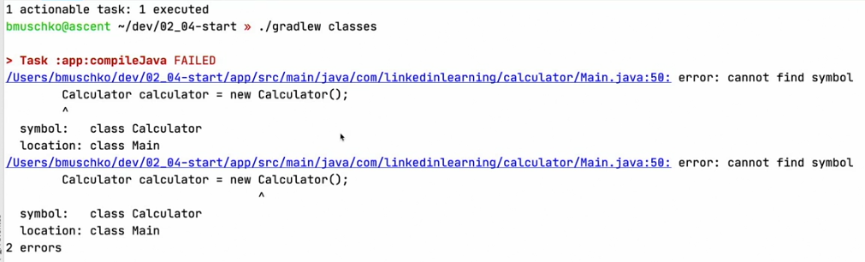

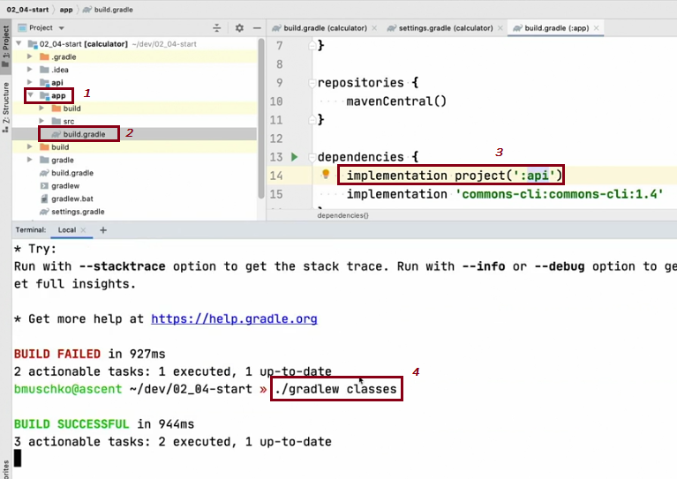

## 14 Using the Maven Publish plugin to publish a library

### ./gradlew publish

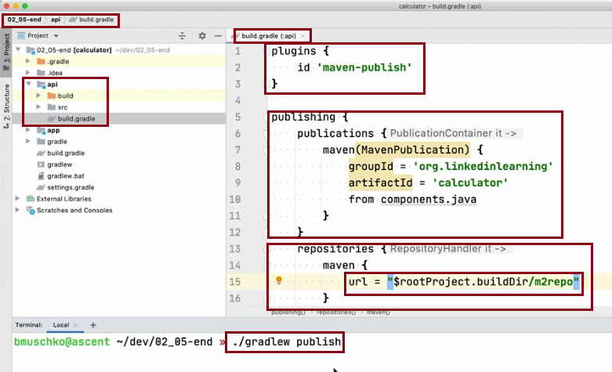

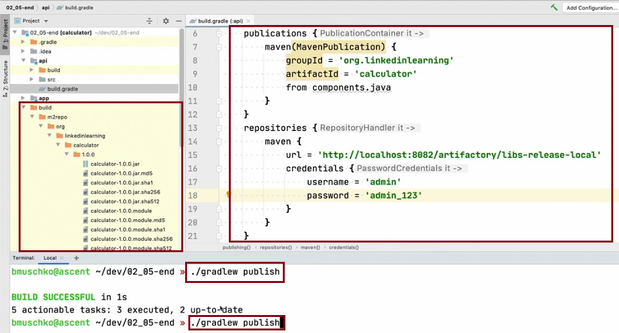

### JFrog Artifactory

#### https://localhost:8082/ui/repos/tree/General/libs-release-local

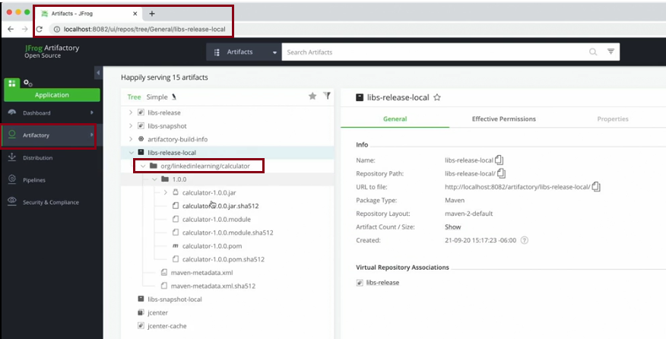

## 15 Challenge Consuming an external dependency

### Challenge: External Dependency

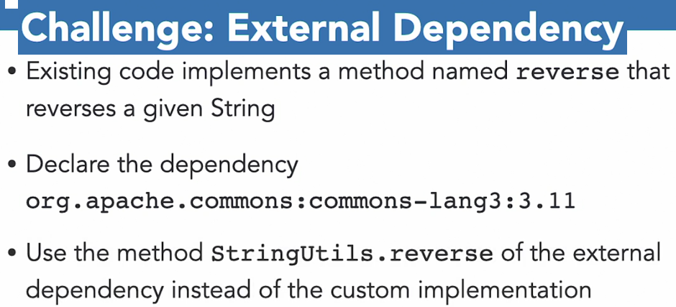

### ./gradlew run

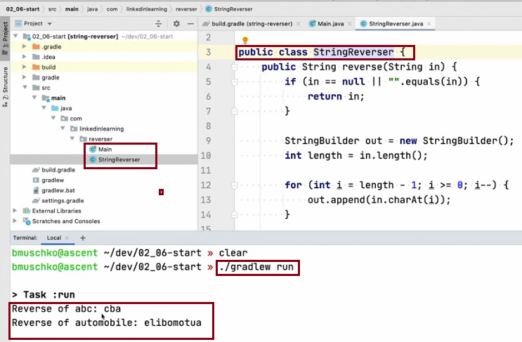

### <https://search.maven.org>

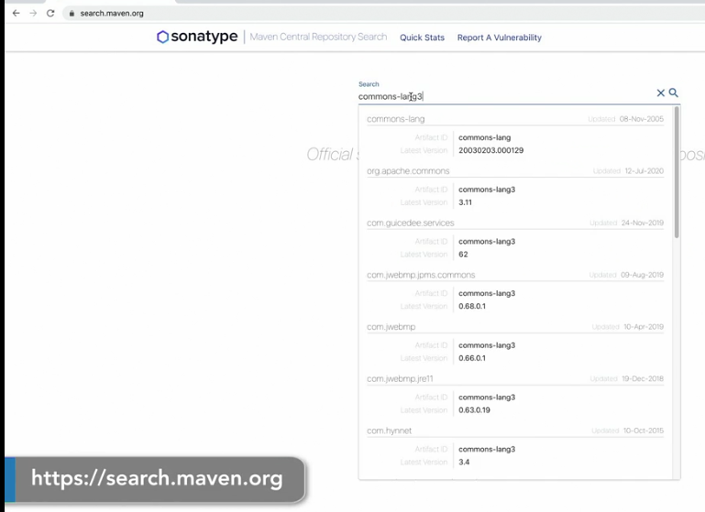

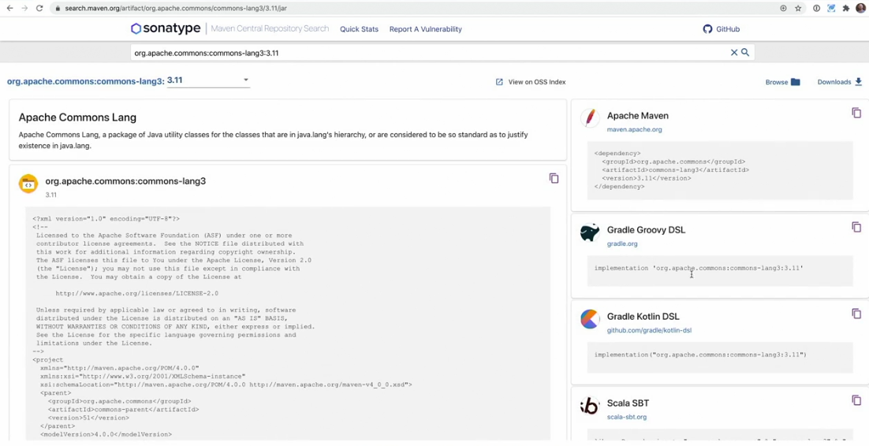

### ./gradlew run

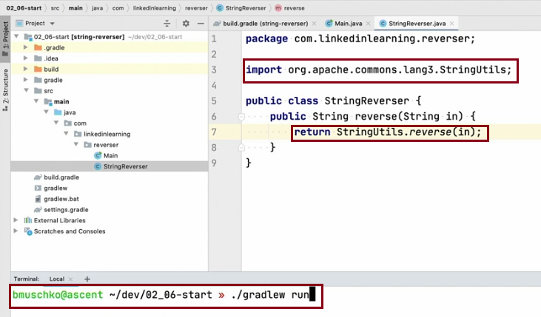

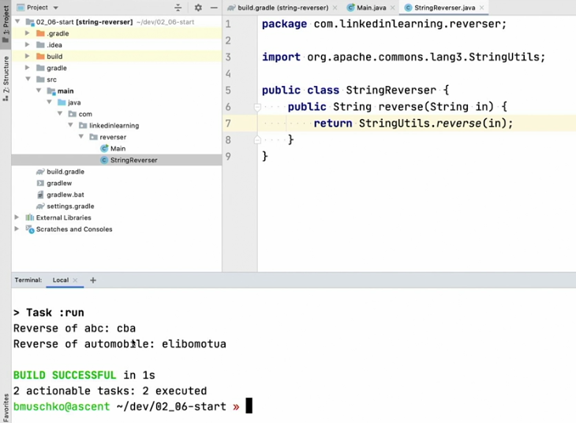

## 17 Using the JUnit 5 test framework

### Testing for Java Projects

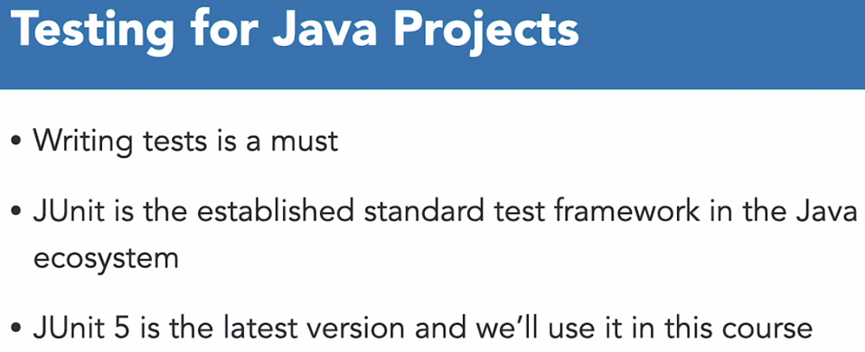

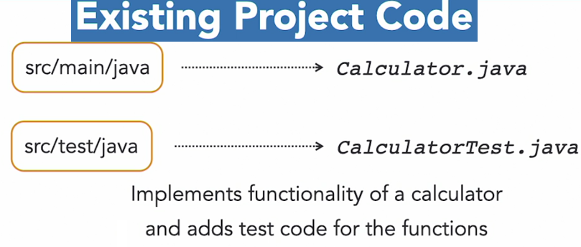

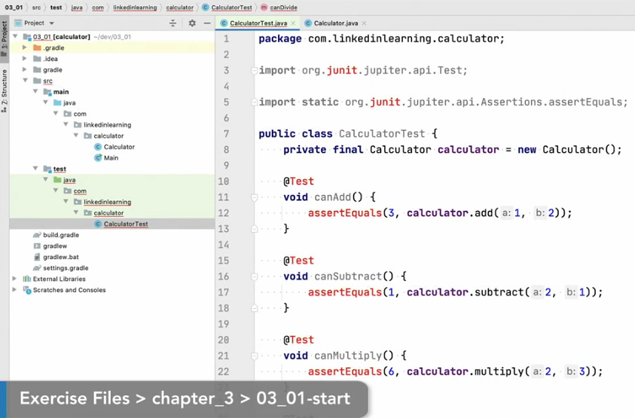

## 18 Declaring JUnit dependencies

### <https://search.maven.org>

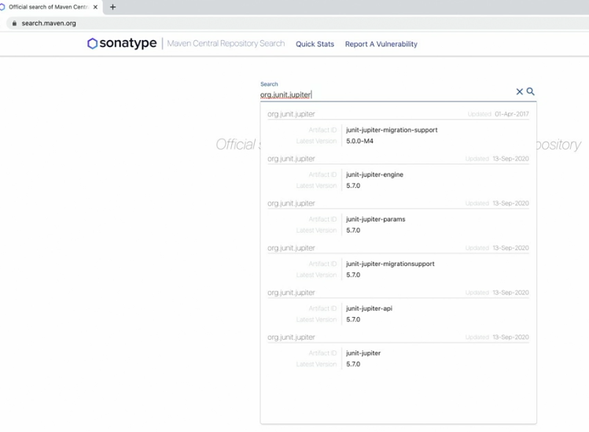

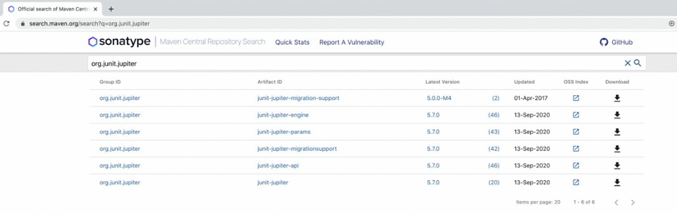

### Test Dependency Configurations

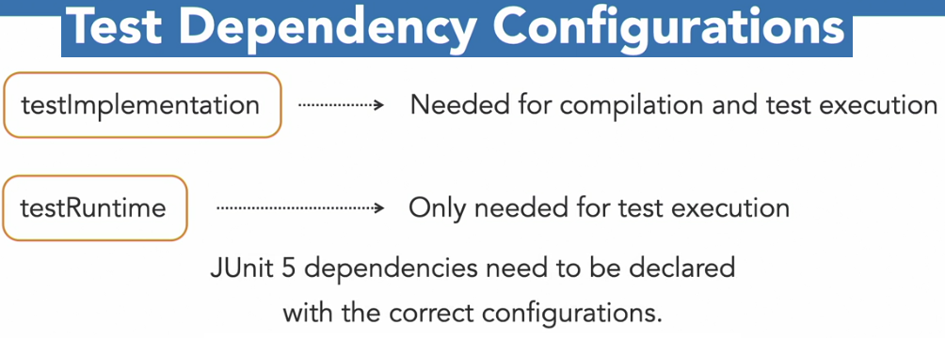

### ./gradlew compileTestJava

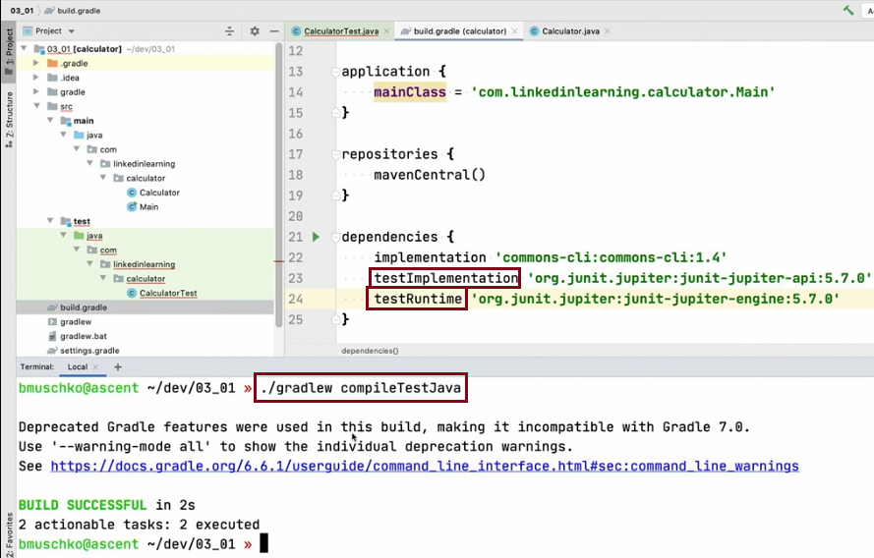

## 19 Executing tests and inspecting the results

### ./gradlew test

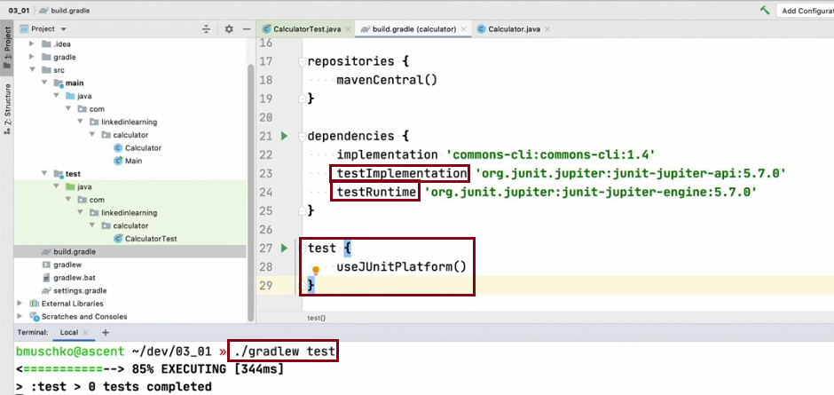

#### ls build/reports/tests/test/index.html

#### ls build/reports/tests/test/index.html

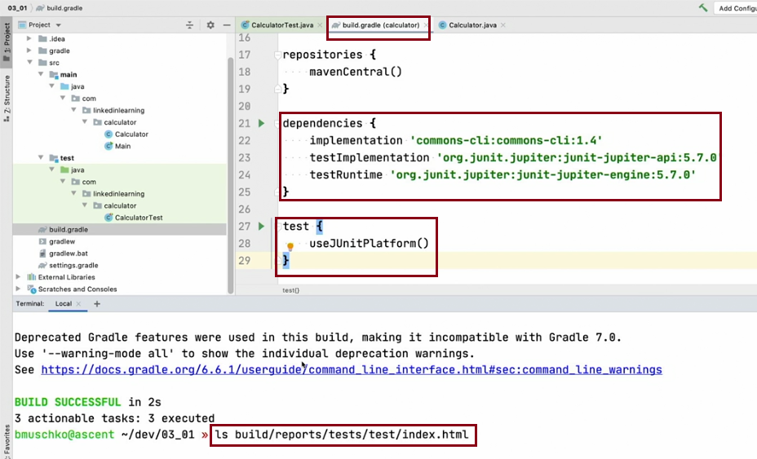

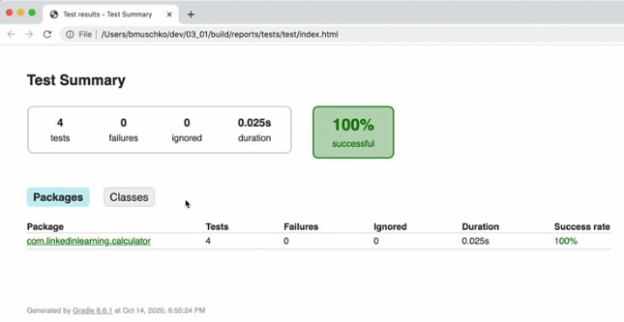

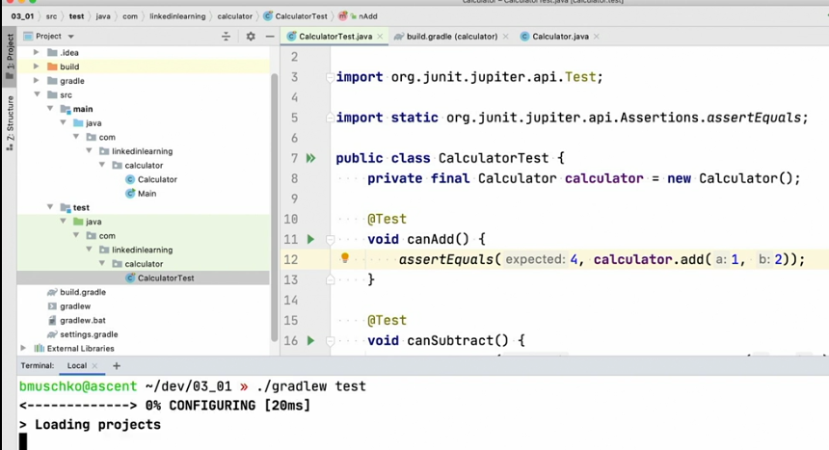

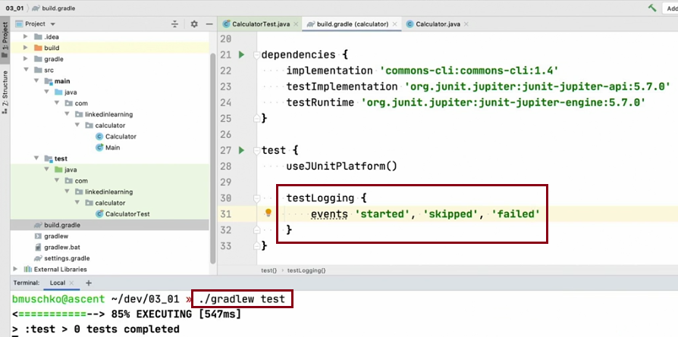

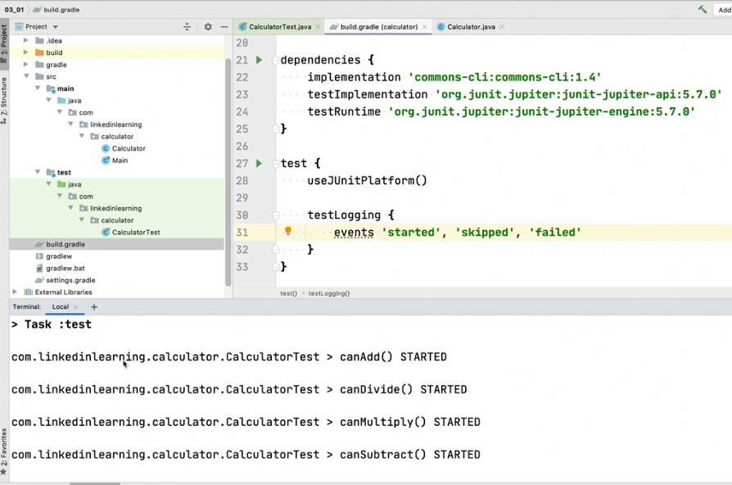

### ls build/test-results/test

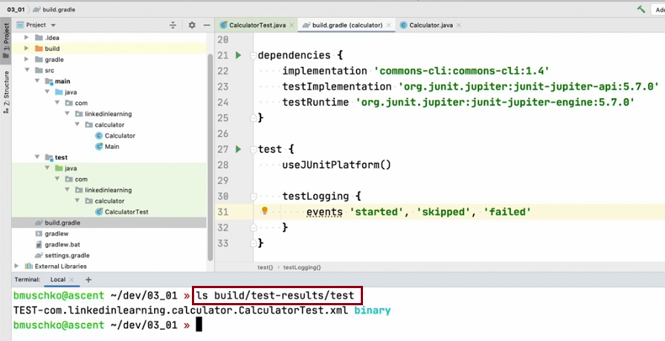

#### ls build/test-results/tests/test/TEST-com.linkedinlearning.calculator.CalculatorTest.xml

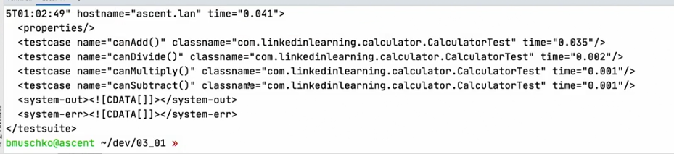

## 20 Challenge Fix a failed test suite

## 21 Solution Fix a failed test suite

./gradlew test

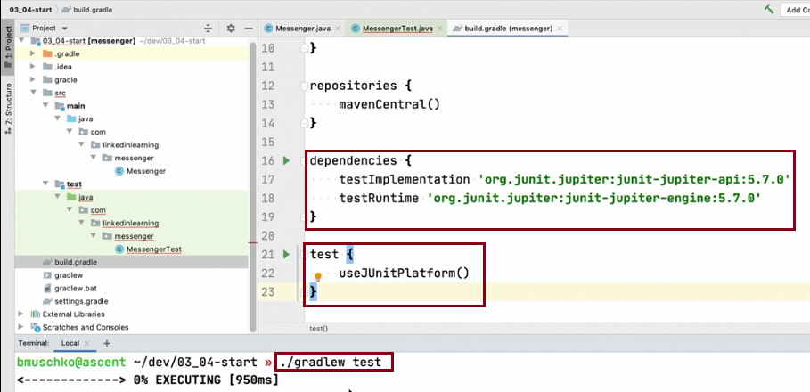

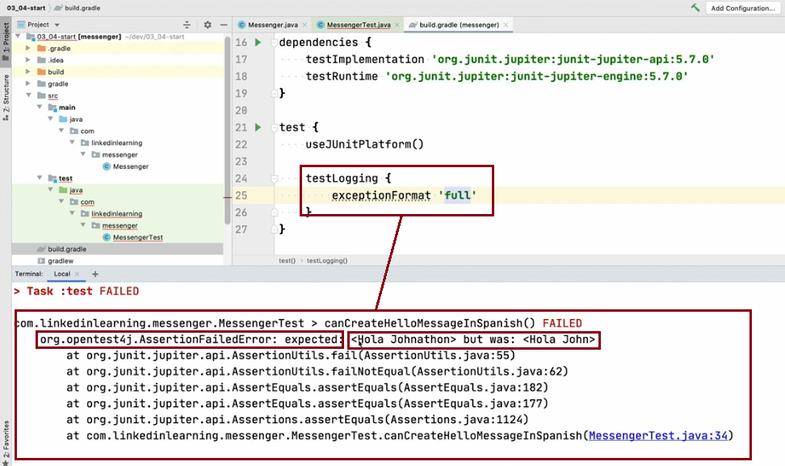

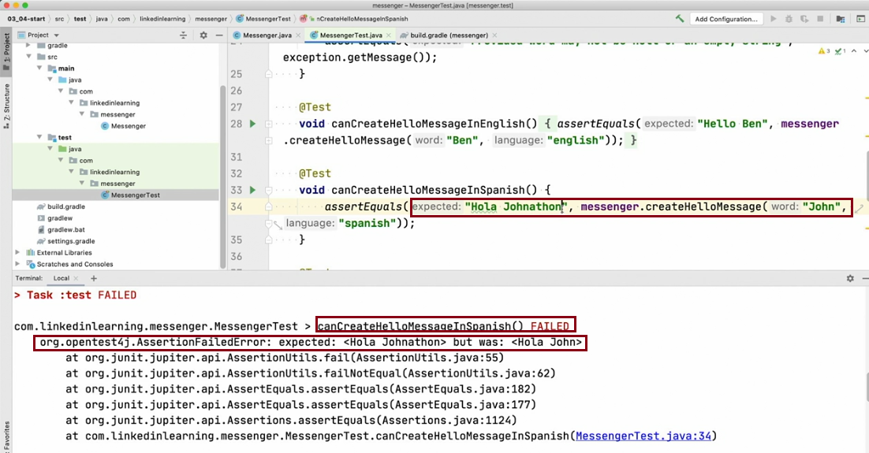

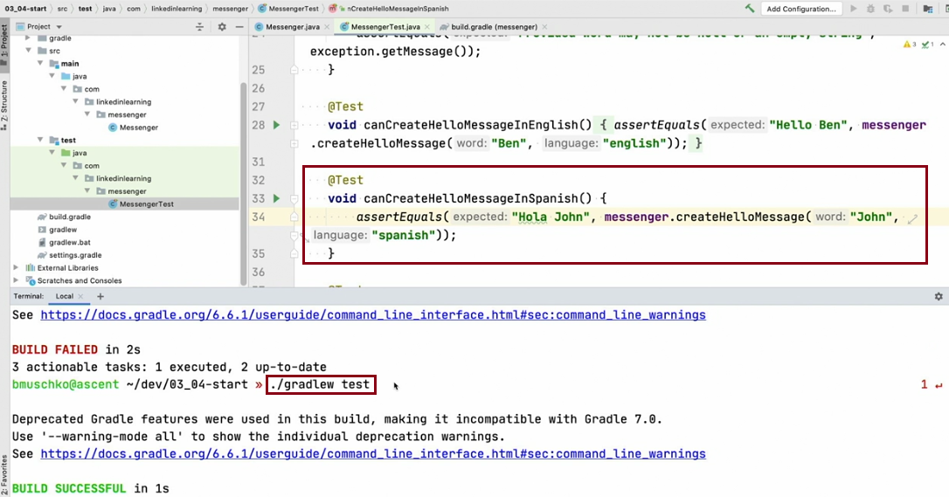

### https://gradle.org

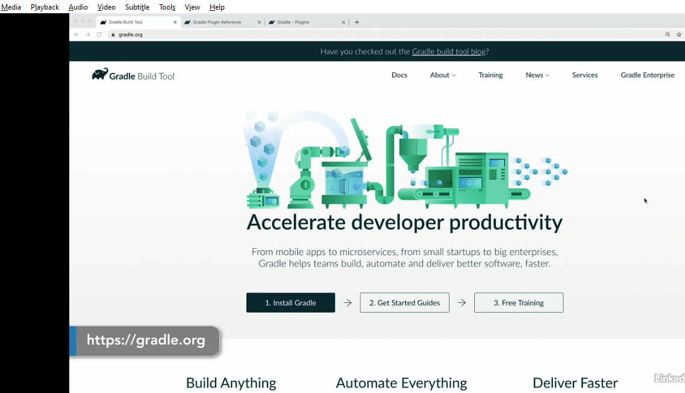

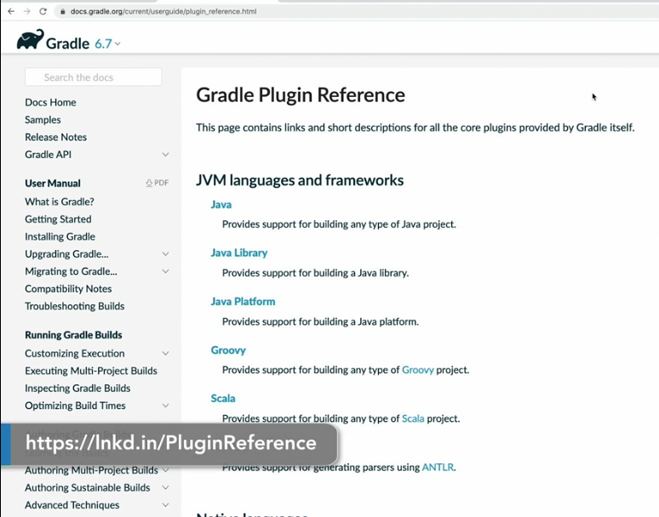

## Run the init task

From inside the new project directory, run the init task using the following command in a terminal: gradle init. When prompted, select the 2: application project type and 3: Java as implementation language. Next you can choose the DSL for writing buildscripts - 1 : Groovy or 2: Kotlin. For the other questions, press enter to use the default values.

The output will look like this:

## $ gradle init

Select type of project to generate:

1: basic

2: application

3: library

4: Gradle plugin

Enter selection (default: basic) [1..4] 2

Select implementation language:

1: C++

2: Groovy

3: Java

4: Kotlin

5: Scala

6: Swift

Enter selection (default: Java) [1..6] 3

Select build script DSL:

1: Groovy

2: Kotlin

Enter selection (default: Groovy) [1..2] 1

Select test framework:

1: JUnit 4

2: TestNG

3: Spock

4: JUnit Jupiter

Enter selection (default: JUnit 4) [1..4]

Project name (default: demo):

Source package (default: demo):

BUILD SUCCESSFUL

2 actionable tasks: 2 executed

The init task generates the new project with the following structure:

|  |  |
| --- | --- |
| GroovyKotlin  ├── gradle  │ └── wrapper  │ ├── gradle-wrapper.jar  │ └── gradle-wrapper.properties  ├── gradlew  ├── gradlew.bat  ├── settings.gradle  └── app  ├── build.gradle  └── src  ├── main  │ └── java  │ └── demo  │ └── App.java  └── test  └── java  └── demo  └── AppTest.java |  |

|  |  |
| --- | --- |
| Generated folder for wrapper files  Gradle wrapper start scripts  Settings file to define build name and subprojects  Build script of app project  Default Java source folder  Default Java test source folder |  |

You now have the project setup to build a Java application.

Review the project files

The settings.gradle(.kts) file has two interesting lines:

GroovyKotlin

## settings.gradle

rootProject.name = 'demo'

include('app')

rootProject.name assigns a name to the build, which overrides the default behavior of naming the build after the directory it’s in. It’s recommended to set a fixed name as the folder might change if the project is shared - e.g. as root of a Git repository.

include("app") defines that the build consists of one subproject called app that contains the actual code and build logic. More subprojects can be added by additional include(…​) statements.

Our build contains one subproject called app that represents the Java application we are building. It is configured in the app/build.gradle(.kts) file:

GroovyKotlin

## app/build.gradle

plugins {

id 'application'

}

repositories {

mavenCentral()

}

dependencies {

testImplementation 'junit:junit:4.13.1'

implementation 'com.google.guava:guava:30.0-jre'

}

application {

mainClass = 'demo.App'

}

Apply the application plugin to add support for building a CLI application in Java.

Use Maven Central for resolving dependencies.

Use JUnit test framework.

This dependency is used by the application.

Define the main class for the application.

The file src/main/java/demo/App.java is shown here:

Generated src/main/java/demo/App.java

/*

* This Java source file was generated by the Gradle 'init' task.

*/

package demo;

public class App {

public String getGreeting() {

return "Hello World!";

}

public static void main(String[] args) {

System.out.println(new App().getGreeting());

}

}

The generated test, src/test/java/demo/App.java is shown next:

Generated src/test/java/demo/AppTest.java

/*

* This Java source file was generated by the Gradle 'init' task.

*/

package demo;

import org.junit.Test;

import static org.junit.Assert.*;

public class AppTest {

@Test public void testAppHasAGreeting() {

App classUnderTest = new App();

assertNotNull("app should have a greeting", classUnderTest.getGreeting());

}

}

The generated test class has a single JUnit 4 test. The test instantiates the App class, invokes a method on it, and checks that it returns the expected value.

Run the application

Thanks to the application plugin, you can run the application directly from the command line. The run task tells Gradle to execute the main method in the class assigned to the mainClass property.

## $ ./gradlew run

> Task :app:run

Hello world!

BUILD SUCCESSFUL

2 actionable tasks: 2 executed

The first time you run the wrapper script, gradlew, there may be a delay while that version of gradle is downloaded and stored locally in your ~/.gradle/wrapper/dists folder.

Bundle the application

The application plugin also bundles the application, with all its dependencies, for you. The archive will also contain a script to start the application with a single command.

$ ./gradlew build

BUILD SUCCESSFUL in 0s

7 actionable tasks: 7 executed

If you run a full build as shown above, Gradle will have produced the archive in two formats for you: app/build/distributions/app.tar and app/build/distributions/app.zip.

Publish a Build Scan

The best way to learn more about what your build is doing behind the scenes, is to publish a build scan. To do so, just run Gradle with the --scan flag.

$ ./gradlew build --scan

BUILD SUCCESSFUL in 0s

7 actionable tasks: 7 executed

Publishing a build scan to scans.gradle.com requires accepting the Gradle Terms of Service defined at https://gradle.com/terms-of-service.

Do you accept these terms? [yes, no] yes

Gradle Terms of Service accepted.

Publishing build scan...

https://gradle.com/s/5u4w3gxeurtd2

Click the link and explore which tasks where executed, which dependencies where downloaded and many more details!